**Bootstrap Lab Assignments**

**Q1) Create a login page using Bootstrap as in the image below.**

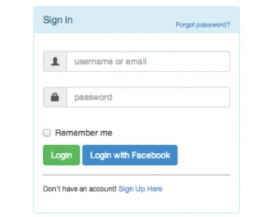

**Q2) Create a drop down menu using bootstrap.**

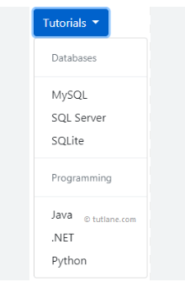

**Q3) Create a list group using Bootstrap as in the image below.**

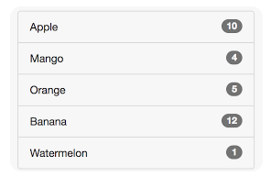

**Q4) Create a page template using Bootstrap grid systems as in the below image.**

